Appetizers

Korean Dumplings 10
beef, veggies, Bulgogi

Roasted Cauliflower 9
romesco, feta cream, scallion

World “Street Food” 14
Arepa, egg roll, empanada

Beet Salad 10
goat cream, dates, red onion

Smashed Meatballs 12
ricotta, romesco, scallion

Gunpowder Potatoes 9
onion, sour orange, cumin

Colombian Buñuelos ^{(limited)} 8
cheese popovers

Fries: Blue Cheese | Tuscan | Belgium 6 ^{each}

Entrees

Add Cheddar | Mushrooms | Bacon ^{+1.50 each} substitutions are politely declined.

Salmon Caesar Salad house crouton, paper onion, house dressing 18

Fried Chicken Chopped Salad candied bacon, gorgonzola, red onion, tomato 18

Salmon Salad honey lime dressing, tomato, paper onion, gorgonzola ^{(limited)} 22

Union Hill Double Cheese Burger oven tomato, cinnamon onion, garlic aioli 16

Double Smokehouse Burger * crispy onion, cheddar, bacon, oven tomato mayo, BBQ 16

Salmon Burger * oven tomato, pineapple slaw, garlic aioli 17

Classic Cuban Pork manchego black beans, rice, sweet plantains, garlic confit 24

Hudson County Fried Chicken garlic mash, brussels hash, piquant honey glaze 19^{half} | 24^{full}

Maryland Crab Cake* oven tomato, dill cream, pineapple slaw, corn, panko 21

Norwegian Salmon* pesto butter, creamed corn, greens 23

Sides: Mushrooms | Plantains | Zucchini | Squash | Creamed Corn | Asparagus 6 ^{each}

Our Chef has won best of Atlanta for “Best Chef” from GA Voice.
He is also a Cutthroat Kitchen Champion!
Watch episodes, “Crab’s of Steel” & “20,000 leagues under the prep table.”
Chef Hernandez is also a certified Wine Consultant through the Court of Master Sommeliers.

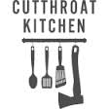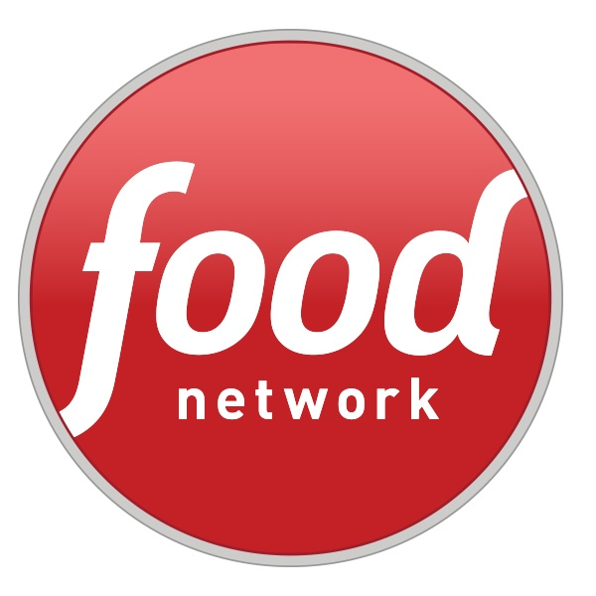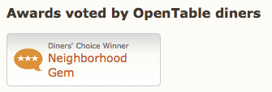

Fine Print
We will happily continue service once you’ve completed your call.
20% gratuity added to parties of 5 or more. No Cry Babies! Be nice, be positive, please do NOT be rude. If you are NOT enjoying what you are eating let us know and we will cheerfully find something else that you will love.
No Nukes! We don’t nuke food or people.

